DAA Lab Experiments (S kannan)

1. First Palindromic String in an Array

Aim
To write a Python program to find the first palindromic string in an array and analyze its complexity.

Algorithm
- Start.
- Create an array containing strings.
- Read each string from the array one by one.
- Reverse the current string.
- Compare the original string with the reversed string.
- If both are equal, it is a palindrome.
- Display the first palindromic string and stop searching.
- If no palindrome is found, display an appropriate message.
- Stop.

Procedure
- Open Python IDLE, VS Code, or any Python compiler.
- Create a list of strings.
- Use a for loop to examine each string.
- Use string slicing [::-1] to reverse each string.
- Compare the original and reversed strings.
- Display the first matching string as the palindrome.
- Execute the program and verify the output.
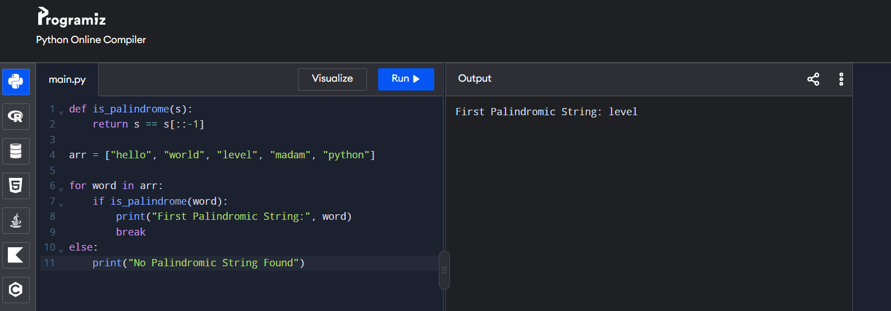

Result : Thus, the Python program successfully identifies the first palindromic string in the given array.

